## **Test Plan (Slider Puzzle)**

|  |  |  |  |  |
| --- | --- | --- | --- | --- |
| **Test Case Number** | **Test Description** | **Expected Result** | **Actual Result** | **Pass/Fail** |
| 1 | Startup of application | Display GUI. | GUI is displayed without errors. | Pass |
| 2 | Select a new puzzle. | Display a new puzzle. | New puzzle displayed without errors. | Pass |
| 3 | Select the image on the puzzle that has the power to swap with adjacent tile until the puzzle is complete. | Once selected, the image will shift to the adjacent tile. Repeat until puzzle is complete. | Image shifts to the adjacent tile until the puzzle is complete. | Pass |
| 4 | Display a message once the user completes the puzzle. | Message displayed once the user has completed the puzzle. | The message is displayed successfully. | Pass |
| 5 | Select a “puzzle hint” to display the puzzle’s final image. | Once a puzzle hint is selected, display the final image of the puzzle. | The final image of the puzzle is displayed. | Pass |
| 6 | Select a new puzzle. | Display a new puzzle for the user to complete. | A new puzzle is successfully displayed. | Pass |
| 7 | Exit slider puzzle window to return to main menu. | Once exited, the user is returned to the main menu. | The user is successfully returned to the main menu. | Pass |

**User Guide: Operation**

1. Select “Slider Puzzle” from the menu to launch the game.

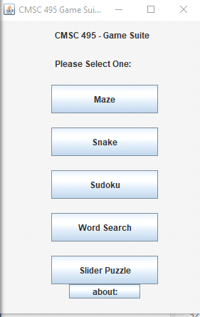

2. Select a new puzzle from the “Choose a puzzle” section of the Slider Puzzle menu.

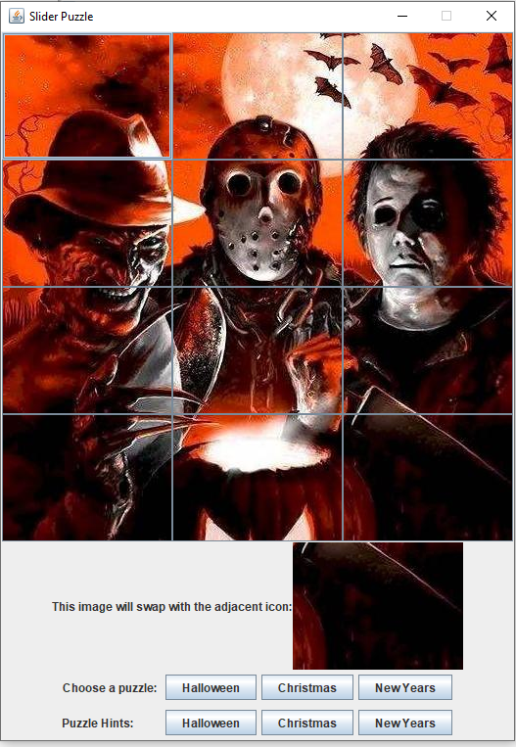

3. Select a puzzle hint, in the “Puzzle Hints” section, to preview the completed puzzle image.



4. Exit the “Hint” window to return to the Slider Puzzle.

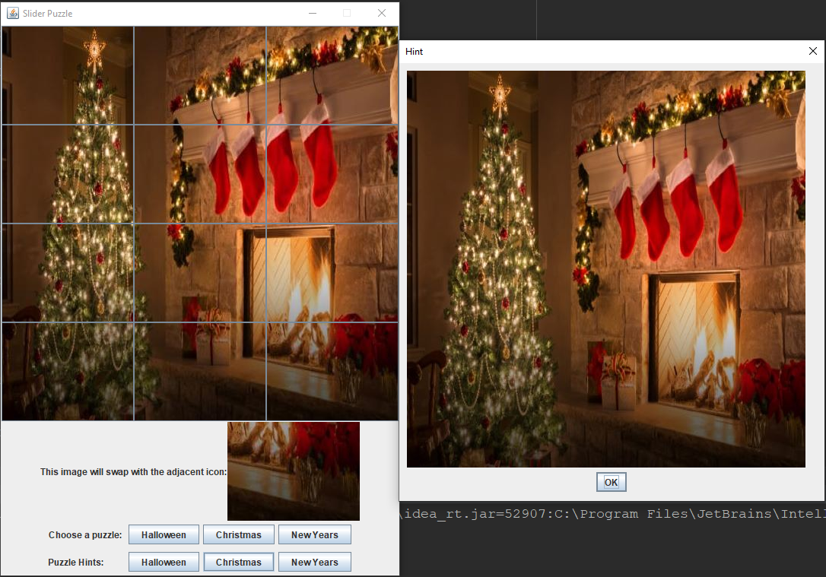

5. Select the image that will swap with the adjacent icon until the puzzle is complete. (Note: A message will appear once the puzzle completed).

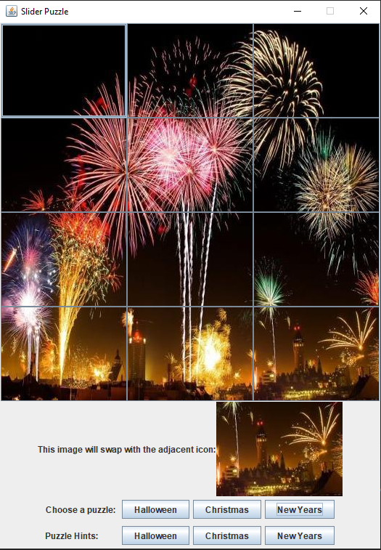

6. Select exit to return to the Game Suite Main Menu.



